**Food tip calculator:**

food = prompt('what was your bill that u ate food? ');

foodpercentage= 0.2;

foodamount= food * foodpercentage;

console.log(foodamount);

**Food tip calculator where amount is entered by user:**

// console.log(fruit);

food = prompt('what was your bill that u ate food? ');

foodpercentage= prompt('tip%')/ 100;

foodamount= food * foodpercentage;

console.log(foodamount);

**rounding off number and adding random number to the screen**

Math.floor(Math.random() *3);  //round off to lower number

Math.ceil(Math.random() *3);  // round off to highest closest number

**Mini weather app:**

let weather = prompt('hows the weather? ');

if(weather == 'rain')

{

    console.log('Grab your umbrella ')

}

else{

    console.log('Grab your sunglasses ')

}

**Functions:**

Functions

function saymyname(name){

    console.log(name);

}

saymyname('sameer');

function greetings(name)

{

     console.log( 'helo ' + name + ' , how are you doing? ')

}

greetings('sameer');

**New method to write the function without concatenation:**

function greetings(name)

{

    greet = `hi ${name}, nice to meet you.`

     console.log( greet)

}

greetings('sameerbuttjee');

**Important terminologies:**

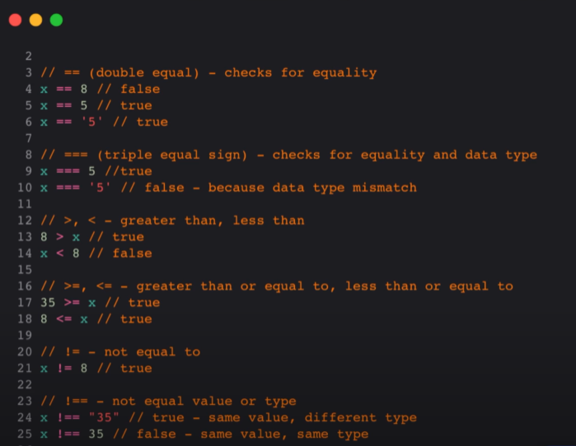

**Functions with arguments: (storing sum in a new variable)**

function sum(a, b)

{

    return a+b;

}

 num1 =sum(2, 3);

console.log(num1);

**Food tip calculator through functions:**

// arrow function of sum with explicit return

const sumbill = (food, tipamount) => food + tipamount;

function totalbillamount(food, tipamount)

{

    return food + tipamount;

}

function foodtipcal(food, tip)

{

tippercentage= tip/ 100;

tipamount= food * tippercentage;

totalbill= totalbillamount(food, tipamount);

console.log(  'Your tip amount will be ' + tipamount);

// console.log('Your total bill wil be ' + totalbill);

 return totalbill;

}

// console.log(foodtipcal(100, 50));

foodi1 =foodtipcal(100, 50);

console.log(foodi1);

**Practice Function exercise:**

 sum = (a, b) =>

 {

    return a + b;

}

  sub = (a, b) =>

 {

    return a - b;

}

  mul = (a, b) =>

{

   return a * b;

}

 div = (a, b) =>

{

   return a / b;

}

 displayresults = () =>{

console.log(sum(2, 2));

console.log(sub(2, 2));

console.log(mul(2, 2));

console.log(div(2, 2));

}

  fullresult=displayresults();

  console.log(fullresult);

**Arrays:**

// Arraays

let groceries= ['apple' , 'banana', 'pear'];

console.log(groceries);

console.log(groceries[0]);

groceries.push('appricot');

console.log(groceries);

console.log(groceries.slice(1,4));

console.log(groceries.indexOf('banana')); //gives us the index of every that elemet which we want to find

console.log(groceries.length);

**Objects:**

const person=

{

    name:'sameer',

shirt: 'black'

}

console.log(person.name);

console.log(person.s

**when u haven’t initialized the object, you can call it right away in main**

person.phone= '03181566195';

console.log(person['phone']);

**Another object example:**

 let person= {

    name: 'Sameer Ali Butt' ,

    Age: '22',

    Degree : 'BSCS',

 }

 console.log(person.name);

 console.log(person.Age);

 console.log(person.Degree);

 person.email_id = 'sameerofficial929@gmail.com';

 console.log(person['email_id']);

**calling objects through functions:**

const introducer = (name, age, assets, dept) => // arrow function with e6

{

let person ={

name :name ,

age: age,

assets: assets,

dept: dept ,

networth: function()

{

    return person.assets - person.dept

}

}

//  const intr0 =

//  console.log('my name is ' + name + 'and my age is ' + age + '.')

const intro = `My name is ${person.name} and my age is ${person.age} and my net worth is $${person.networth()}`; //`` template literals

return intro;

}

console.log(introducer('sameer', 22, 200, 50));

**Loops:**

**(old and ugly way to write for loops in javascript)**

//Loops

let fruits= ['apple' , 'banana', 'pear', 'guaava' ,'annar', 'chiknder'];

for( i=0; i<fruits.length; i++)

{

console.log(i  + '-' + fruits[i]);

}

**New way to write for loops:**

for ( let sameer of fruits){

    console.log(sameer);

}

**Writing loop of numbers, doubling it and then storing in new array:**

 let numbers =[1, 2, 3, 4, 5, 6, 7, 8, 9, 10];

 let results= [];

 let store;

 for (sameer of numbers)

{

     console.log(sameer*2);

     results.push(sameer*2);

}

console.log(results);

**Writing a function(augmented function with one variable) have a loop in it and storing the data of that function in a resultant array: (double)**

const functionloop = (numbers) =>

{

let result =[];

for (sameer of numbers)

{

    result.push(sameer*2);

}

return result ;

}

console.log(functionloop([1, 2, 3, 4, 5, 6]));

**Writing a function(augmented function with one variable) have a loop in it and storing the data of that function in a resultant array (squaring numbers)**

const functionloop = (numbers) =>

{

let result =[];

for (sameer of numbers)

{

    result.push(sameer**2);

}

return result ;

}

console.log(functionloop([1, 2, 3, 4, 5, 6]));

**Array with loops and objects**

**Function to count letter in a phrase (old way)**

 const lettercounter = () =>

 {

    let paragraph = ' my name is sameer and i am learning javascript and i am learning js from rafay qazi who has ayoutube cahnnel of name clever prgramming .';

    for (letters in paragraph)

    {

        console.log( Number(letters) + 1);

    }//old way of writing this type of program

 }

 lettercounter();

**Function to count letter in a phrase and storing the result in a new number:**

let result=0;

 const lettercounter = () =>

 {

    let paragraph = ' my name is sameer and i am learning javascript and i am learning js from rafay qazi who has ayoutube cahnnel of name clever prgramming  and alhmadulillah i am doing good.';

    for (letters in paragraph)

    {

        console.log( Number(letters) + 1);

        result=Number(letters) + 1;

    }

    return { result };

 }

 console.log(lettercounter());

**taking the phrase from user of the above program:**

const lettercounter = (paragraph) =>

 {

   let result=0;

    for (letters in paragraph)

    {

        console.log( Number(letters) + 1);

        result=Number(letters) + 1;

    }

    return { result };

 }

 let paragraph = prompt('write your paragraph');

 console.log(lettercounter(paragraph));

**how to know length of a word of phrase(.length)**

'banana'.length

6

**Replacing above all code with .length attribute:**

 const lettercounter = (paragraph) =>

 {

    return { result:paragraph.length };

 }

 let paragraph = prompt('write your paragraph');

 console.log(lettercounter(paragraph));

**Writing a function which sums all the number is the array and add them through some for loop:**

**(Old way)**

const sumnumarray = () =>

{

    const nummarray=[1, 3, 4, 5];

    let result = 0;

    for(let i=0; i<5; i++)

    // for( const sameer of nummarray)

    {

        // console.log(sameer); //old waaayyyyyy

        console.log(i);

        result = result + i ;

    }

    return  {'sum of the array is ':result} ;

}

console.log(sumnumarray());

**(modern way)**

const sumnumarray = ()=>

{

let nummarray=[1, 2, 3, 4, 5];

let result=0;

for(number of nummarray) //new wayyyyy

{

    console.log(number);

    result = result + number;

}

return {'Sum of numbers in the array are ':result} ;

}

console.log(sumnumarray());

**Finding a maximum number from a given array:**

const max = (numbers) =>

{

let result= numbers[0];

for (  number of numbers)

{

    if(number > result)

    {

        result = number;

    }

}

return result;

}

console.log(max([0, 1, 2, ,3, 4, 5, 6, 22, 88, 4, 3, 96, 8, 632, 148, 3625, 8896, 1452, 99999]));

**Writing a program which find the letter frequency tells the number of same letters in the word:**

const letterfrequency = (phrase) =>

{

// let phrase = 'hahaha'

let frequency= {};

for ( letter of phrase)

{

    console.log(letter);

    if( letter in frequency)

    {

frequency[letter] = frequency[letter] +1;

    }

    else{

        frequency[letter] =1;

    }

}

return frequency;

}

console.log(letterfrequency('my name is sameer and i am learning javascript from cleevr programming.'));

**Finding a word frequency through split program then storing it in an array:**

const wordfrequency = (phrase) => {

    let frequency = {}

    let array = phrase.split(' ')

    console.log(array);

    for (word of array)

     {

        if (word in frequency)

         {

            frequency[word] = frequency[word] + 1;

         }

         else

         {

            frequency[word] = 1;

         }

    }

    return frequency;

}

console.log(wordfrequency('lol how are u lol how'));

**Filter operation**

const filter = (numbers, gratertthan) => {

    let results = [];

    for (number of numbers)

    {

        if (number > gratertthan)

        {

            results.push(number);

        }

        else

         {

            console.log('NULL')

        }

    }

    return results;

}

console.log(filter([1, 2, 3, 4, 5, 6, 7], 3));

**New method for filter as filter gives us ana array:**

const nums=[1, 2, 3, 4, 5, 6];

console.log(nums.filter(num => num > 3)); //filter always gives us the the array result but map doesnt

**Navigating the DOM**

Displaying data of html on console screen

let companyname= document.getElementById(comname);

console.log(comname.innerText)